SOLUTION
PROBLEM IN LECTURE NOTES (Session 9-52)

a. 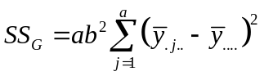 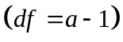

For the problem under consideration: 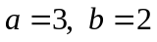
Hence, 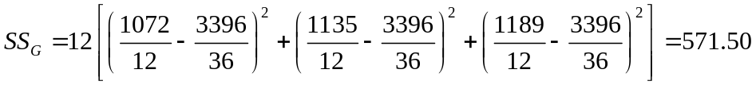
b. 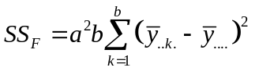 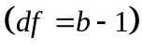

Hence, 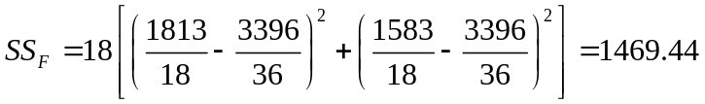
c. 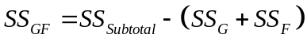 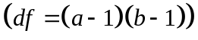

in which, 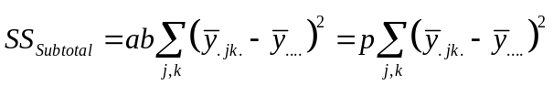

Hence, 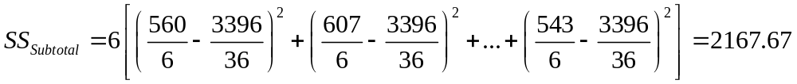
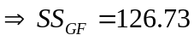
d. 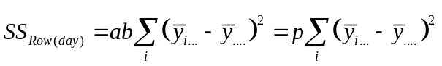 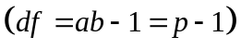

Hence, 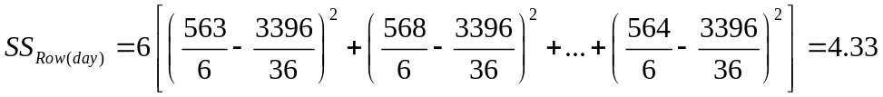
e. 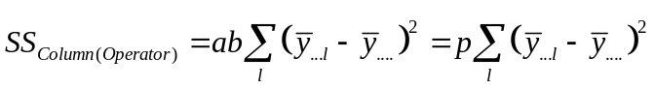

Hence,
f. 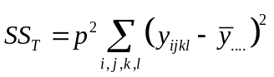 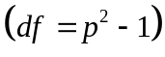

Hence,